

Course code: 9P104
Civic Issue Reporting Management System
A Project Report submitted in partial fullfilment
of the requirements for

Submitted by:
NAME | REGISTRATION NUMBER
Pavan Kalyan Kanugonda | 12306117
Hemanth Bandaru | 12318160
Aatla Manikanta Eswar Reddy | 12312809
Surya Prakash Kotte | 12319239

Submitted to
Akhand Pratap Singh
Department of Computer Science & Engineering
Lovely Professional University

ACKNOWLEDGEMENT
We express our sincere gratitude to everyone who contributed to the successful completion of the Civic Issue Reporting Management System project.
We would like to extend our heartfelt thanks to our respected Project Guide for their constant guidance, encouragement, and valuable suggestions throughout the development of this project. Their support helped us gain deeper insights into full-stack application development.
We are thankful to our Head of the Department and all the faculty members for providing the necessary facilities, resources, and motivation to carry out this project successfully.
We also express our gratitude to our college management for offering a supportive learning environment and the infrastructure required for implementing this project.
We would like to acknowledge the efforts of our team members for their cooperation, dedication, and teamwork. Each member contributed effectively in frontend development, backend logic, database management, testing, and integration, which made this project a successful one.

DECLARATION
We hereby declare that the project titled “Civic Issue Reporting Management System” is an original work carried out by us under the guidance of our project guide. This project work has not been submitted earlier to any other university or institution for the award of any degree or diploma.
All the information, data, and results presented in this project are based on our own efforts and study. Wherever references from other sources have been used, they have been duly acknowledged.
We further declare that this project is carried out in partial fullfilment of the requirements for the award of the degree and complies with all the academic rules and regulations of the institution.

Signature:
Pavan Kalyan Kanugonda
(12306117)

INDEX
- Introduction
- Modules
- Tools Used
- Languages Used
- Screenshots (Output)
- GitHub Link
- Social Media (Likes, Shares, Comments)
- Client Documents
- Deployment Link (Revenue Based)

INTRODUCTION
In today’s rapidly growing urban environment, managing civic issues efficiently has become a major challenge for municipal authorities. Problems such as road damage, water leakage, garbage overflow, streetlight failure, and drainage issues require immediate attention to ensure public safety and quality of life. Traditional complaint systems are often time-consuming, inefficient, and lack transparency.
The Civic Issue Reporting Management System is a web-based application designed to provide a simple, efficient, and transparent platform for citizens to report civic issues online. This system allows users to register, log in securely, and submit complaints related to various public infrastructure problems. Each complaint is stored in a centralized database, enabling authorities to track, manage, and resolve issues effectively.
The system eliminates manual paperwork and reduces communication gaps between citizens and municipal authorities. It ensures faster response times, proper documentation, and improved accountability. Users can also view the status of their reported issues, which increases transparency and trust in the system.
By integrating modern technologies such as Spring Boot for backend, MySQL for database management, and React with HTML, CSS, and JavaScript for frontend, the system offers a robust and scalable solution for civic issue management. This project aims to contribute towards the development of smart cities by improving public service delivery through digital solutions.

MODULES
The Civic Issue Reporting Management System is divided into several functional modules to ensure smooth operation and efficient management of civic complaints. Each module performs a specific role in the system.

1. User Registration & Authentication Module
This module allows users to create an account and securely log in to the system.
Features include:
- User registration using email and password
- OTP-based verification for secure access
- Login and logout functionality
- Session management for authenticated users
This module ensures that only authorized users can report and track civic issues.

2. User Dashboard Module
The dashboard provides users with an overview of their activities.
Key functionalities:
- View user profile details
- Display all complaints raised by the user
- Track complaint status (Pending, In Progress, Resolved)
- Easy navigation to report new issues
This module enhances user experience by providing centralized access to all features.

3. Complaint Reporting Module
This module enables users to raise civic complaints easily.
Features include:
- Submission of issues with title and description
- Category selection (Road, Water, Electricity, Sanitation, etc.)
- Automatic complaint ID generation
- Storing complaint details in the database
It acts as the core module of the system.

4. Complaint Management Module
This module is mainly used by administrators or authorities.
Functions include:
- View all complaints submitted by users
- Update complaint status
- Assign complaints to concerned departments
- Monitor issue resolution progress
This module improves accountability and systematic handling of complaints.

5. Database Management Module
This module manages all data storage and retrieval operations.
Responsibilities:
- Store user information securely
- Maintain complaint records
- Manage OTP and authentication data
- Ensure data consistency using MySQL
It forms the backbone of the system.

6. Notification & OTP Module
This module handles communication with users.
Features:
- OTP generation and verification
- Email notifications for login and complaint submission
- Alerts on complaint status updates
This module improves system security and user awareness.

7. Frontend Interface Module
This module focuses on user interaction and presentation.
Technologies used:
- React for dynamic UI
- HTML and CSS for structure and styling
- JavaScript for interactive components
- Chatbot integration for assistance
It ensures an attractive, responsive, and user-friendly interface.

8. Backend Service Module
This module handles all business logic.
Responsibilities:
- REST API creation using Spring Boot
- Validation of user inputs
- Handling requests from frontend
- Communicating with database
This module ensures smooth coordination between frontend and database.

9. Chatbot Assistance Module
This module provides instant help to users.
Features:
- Answer common civic-related queries
- Provide helpline numbers
- Guide users to raise complaints
- Improve overall user engagement

TOOLS USED
The development of the Civic Issue Reporting Management System involved various tools and technologies to ensure efficient design, development, testing, and deployment of the application.

1. Frontend Tools
React.js
- Used to build a dynamic and responsive user interface
- Component-based architecture improves reusability
- Handles routing, state management, and API integration
HTML5
- Used for structuring web pages
- Provides semantic elements for better accessibility
CSS3
- Used for styling the user interface
- Ensures responsive and user-friendly design
- Enhances visual appearance
JavaScript
- Used for client-side logic
- Handles form validation and API calls
- Improves interactivity

2. Backend Tools
Spring Boot
- Used to develop RESTful APIs
- Simplifies backend configuration
- Handles business logic and request processing
Java
- Core programming language for backend development
- Provides security, scalability, and performance

3. Database Tools
MySQL
- Used to store user and complaint data
- Ensures data consistency and reliability
- Supports relational data management

4. Development Tools
Visual Studio Code
- Used as the primary code editor
- Supports extensions for Java, React, and Git
- Improves productivity
Apache Maven
- Used for project build and dependency management
- Simplifies library management in backend

5. Testing Tools
Postman
- Used to test REST APIs
- Verifies request and response handling
- Ensures backend correctness

6. Version Control Tools
Git
- Used for version control
- Tracks changes in source code
- Supports collaborative development
GitHub
- Used to host the project repository
- Enables teamwork and code sharing

7. Email & Notification Tools
JavaMailSender
- Used for sending OTPs and notifications via email
- Improves security and user verification

8. Browser Tools
Google Chrome
- Used for testing frontend UI
- Helps in debugging using developer tools

9. Deployment & Runtime Tools
Apache Tomcat (Embedded)
- Used to run the Spring Boot application
- Handles HTTP requests and responses
SCREENSHOTS (OUTPUT)
The following screenshots demonstrate the working of the application:
Admin Register page
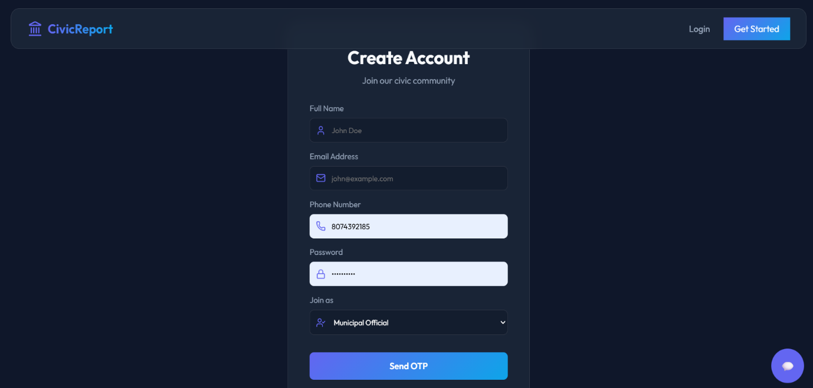
Public register page
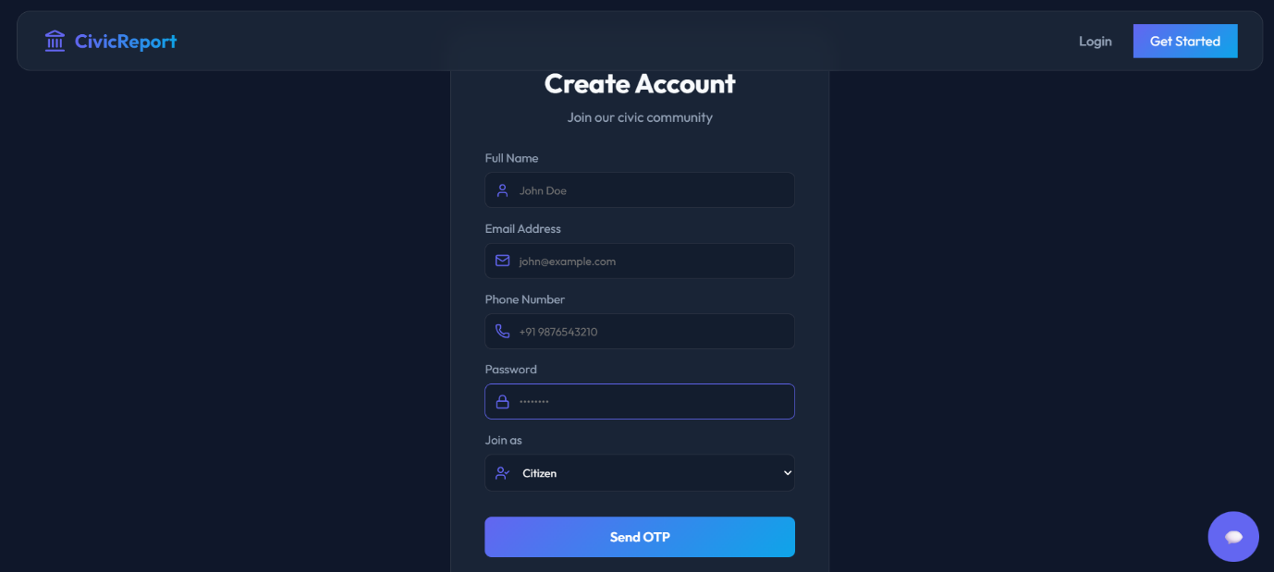

Chatbot
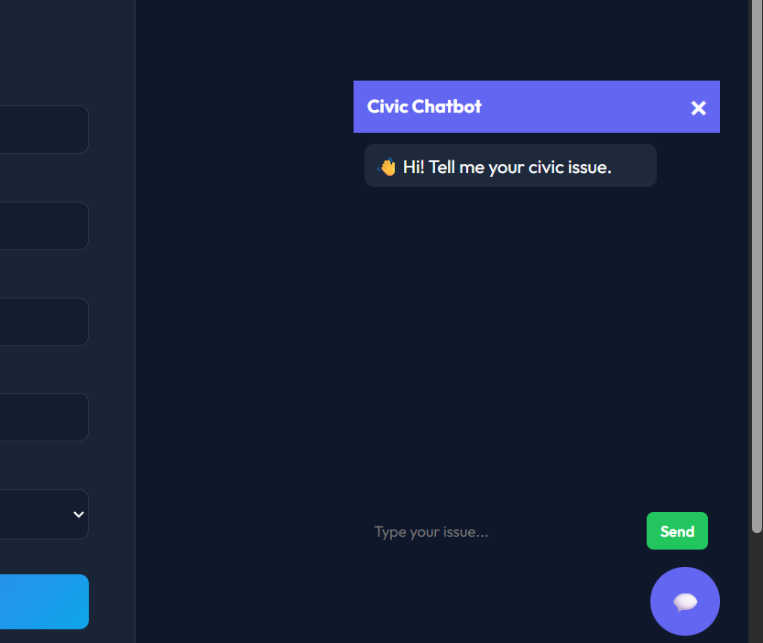

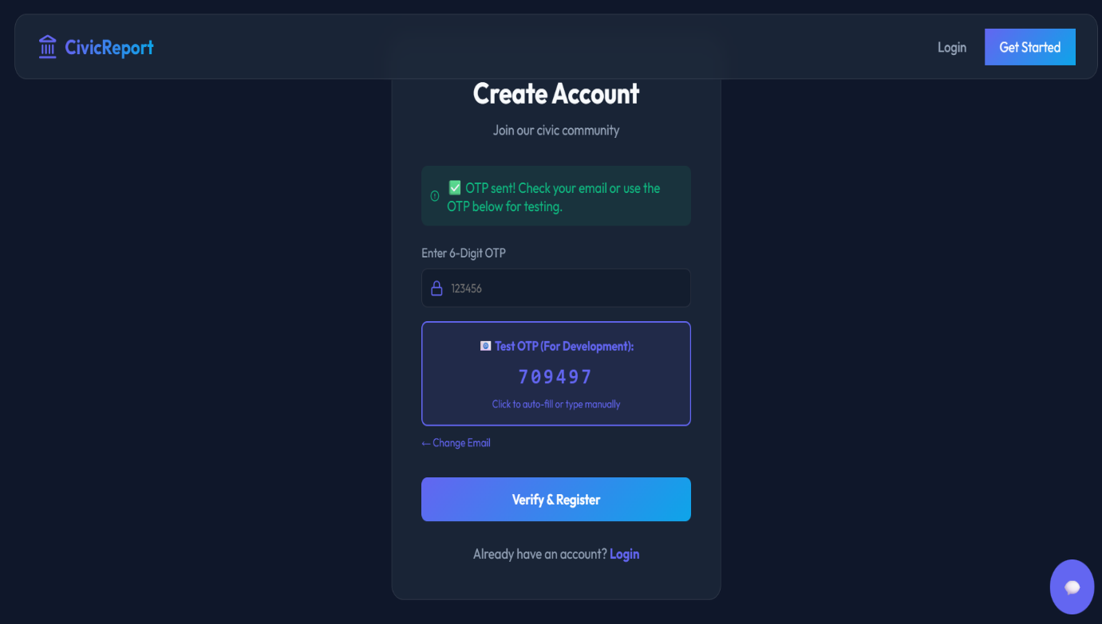


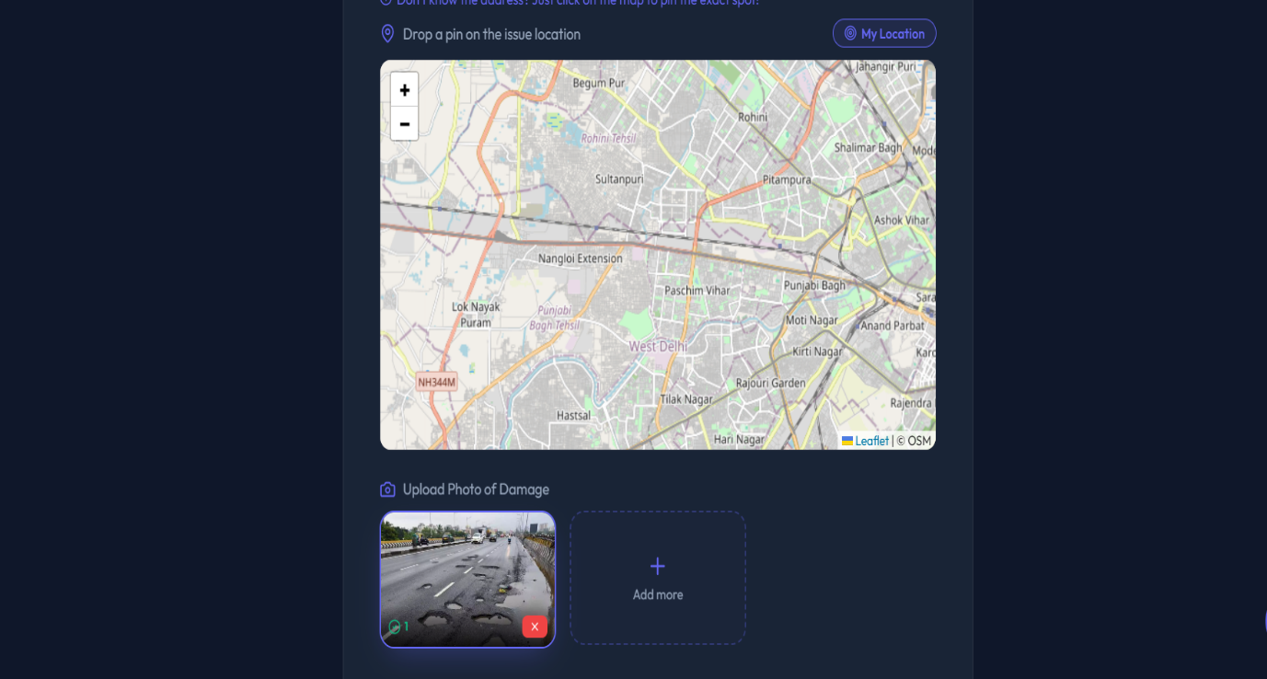


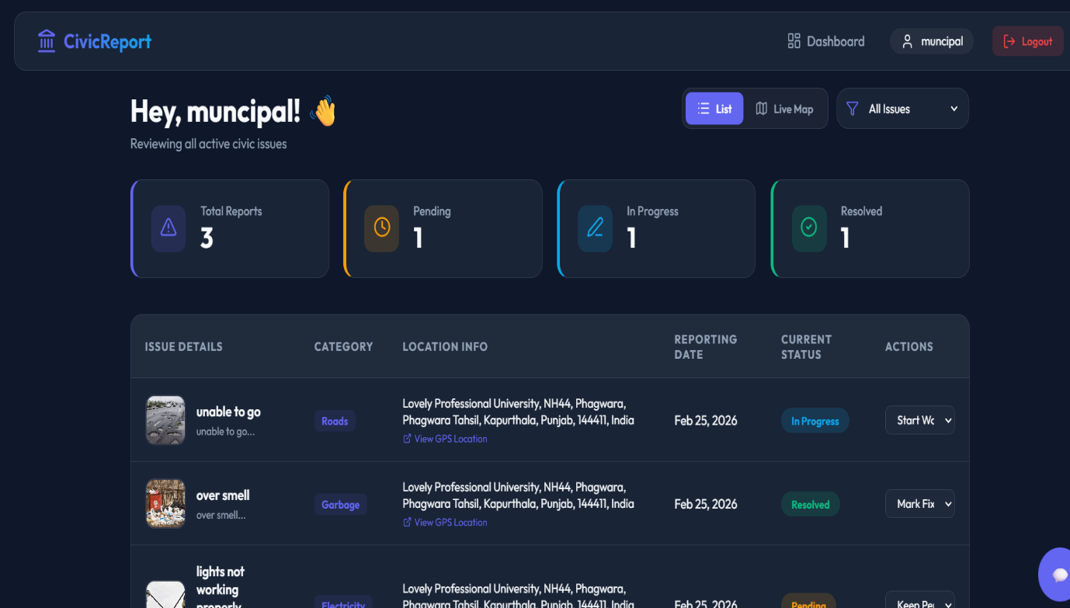

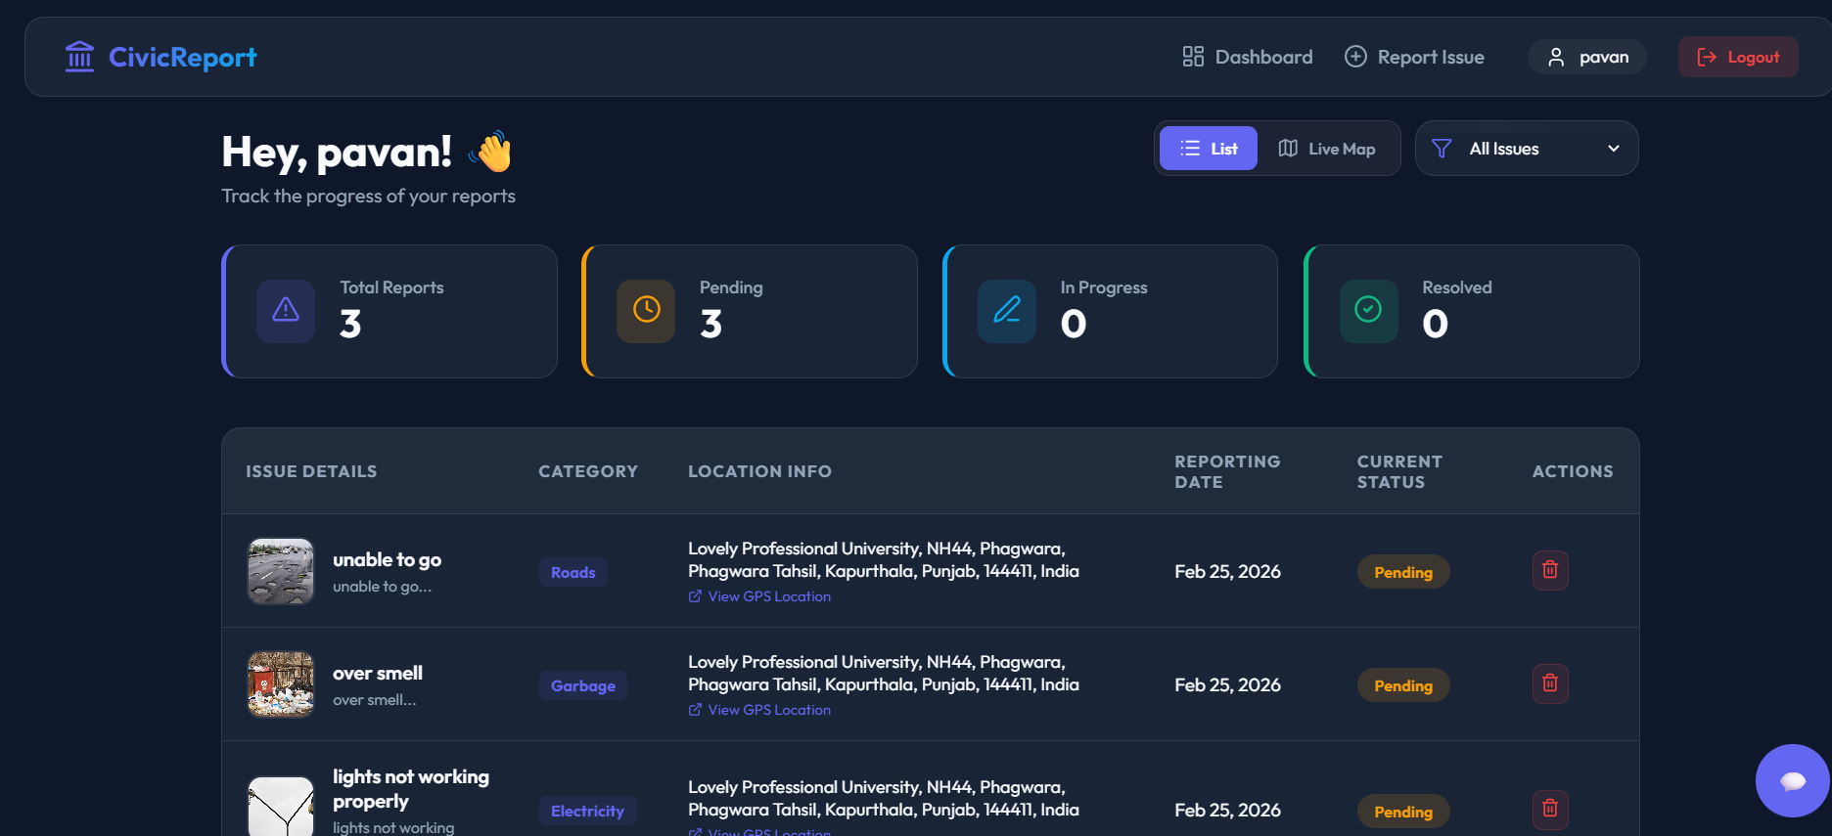
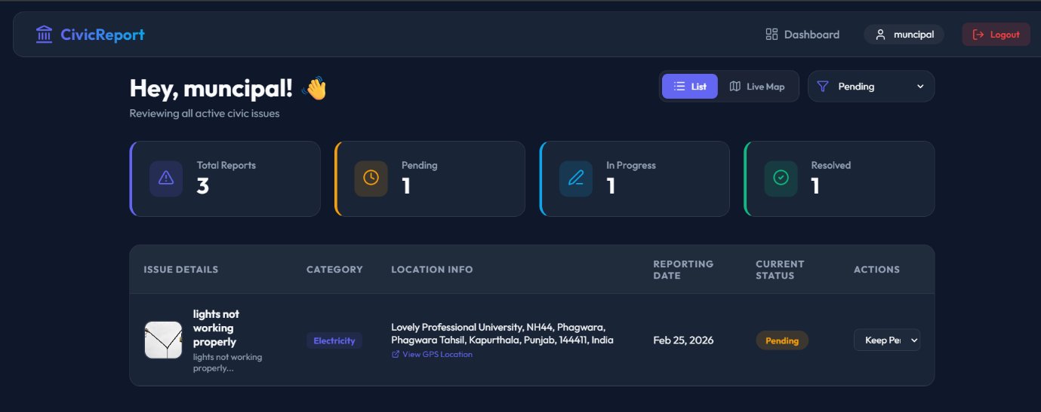
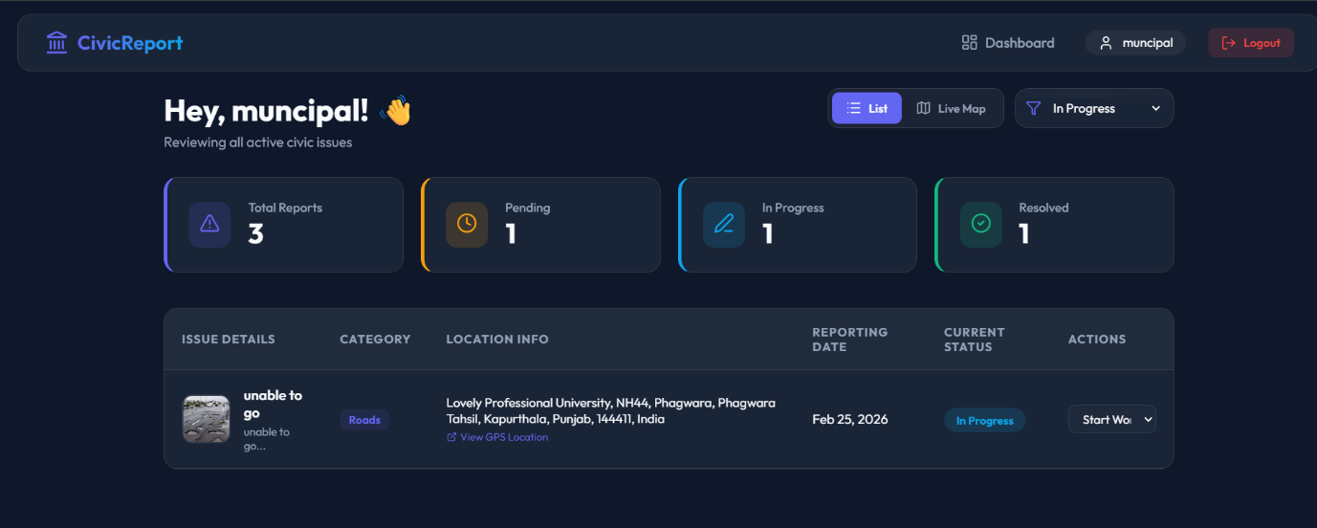

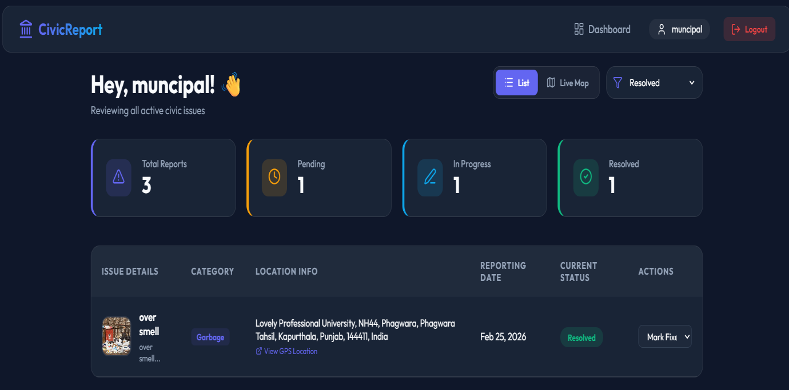

GITHUB LINK
The complete source code of the LAND REAL E-STATE project is available at:
https://github.com/pavankalyankanugonda
This repository contains frontend, backend, and configuration files.

